|  |
| --- |
| | |

|  |  |
| --- | --- |
| Brewsoft | Moobley Functional Specification |

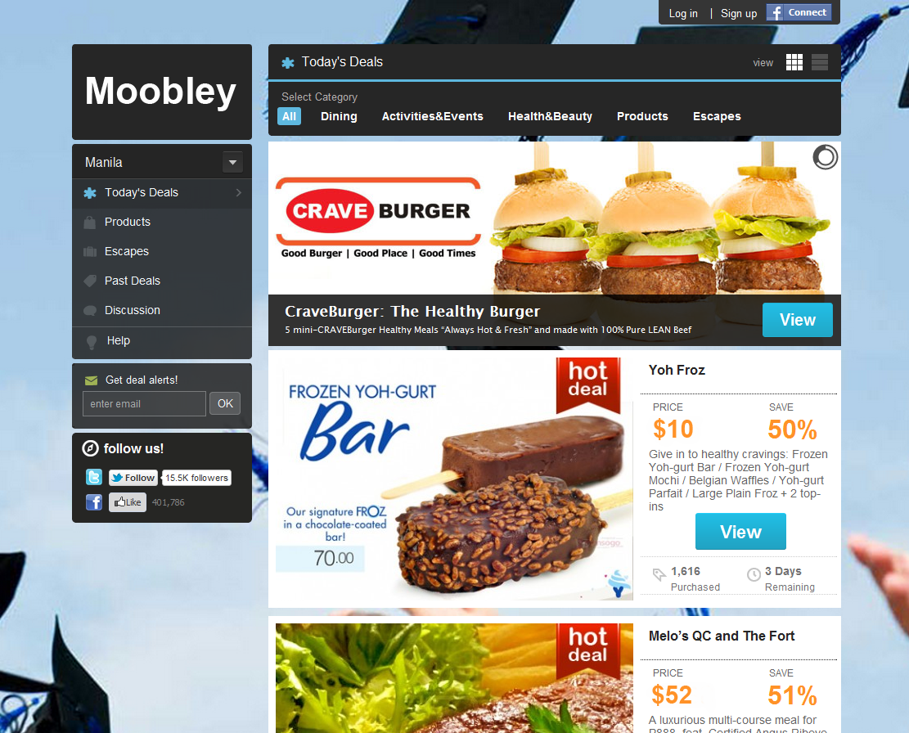

Introduction

# Project Description:

Coupons and rebates are used to increase sales and promote consumer loyalty. The goals of coupon and rebate programs are usually the same and can include: encourage repeat purchase, increasing product awareness, getting consumers to try a new product, moving overstocked inventory, targeting specific markets, softening the blow of price increase, launching a new marketing campaign, trading consumers up, and respond to competitive pressure.

Moobley is a web based system that solves these common problems mall operators and store owners face in traditional retail coupons like planning, scheduling, printing/reprinting, and mailing costs. Even then, customers can forget to bring in their redeemable coupon. Moobley combines the power of electronic coupons and the convenience of mobile phones with its Android, Windows, and iOS client. Moobley maximizes the Malls' and Stores marketing strategy with the speed, convenience, and positive return from Mobile Coupons.

# Moobley Makes:

* Storing information of tenants, their products and services and prices, and contact persons - Customer Database.
* Scan, upload, store, track important electronic documents and/or images of paper documents such as tenant requirements, communications, etc. with the built in Document Management System.
* Coordinate the multi-channel service and support given to the customer by providing the infrastructure for responsive and effective support to customer issues, questions, complaints, etc.
* Helps store owners create coupons with unique coupon code for easy redemption.
* Track redemption rates and revenue earned
* Allows customers to bring a copy of the purchased coupon in their phone.
* Send feedback
* Submit complaints and support tickets
* Mall has a database of Merchants, Stores, Contact Information and Products and services they sell
* Customer information and purchasing habits

# Features:

* LOCALIZED - Shows your coupon to shoppers right in a specified Mall area.
* PUSH NOTIFICATIONS - Real hourly notification for new offers
* YOU HAVE THE POWER - Store owners have full control of offers, including expiration date, usage limits, etc.
* FAST & EASY - No lead time, no production time. Once the offer is approved, it goes live.
* TRACK IT - Advanced analytics let the Store Owner determine which offers are working and which aren't.
* ENVIRONMENT - No paper or ink. It is environmentally friendly.
* SAVE MONEY - A cost-effective way of bringing customers into the store.

# How It Works:

Moboley is a 3 step process:

1. Delivery
   1. The coupon is pushed into smart phones and other supported web enabled devices with the intervention of the user.
   2. Moobley has an website where users can browse and check for new coupons
   3. Taskbar notification
2. Purchase
   1. The customer purchases the coupon using credit card
   2. Customer may also purchase using rewards points
3. Redemption
   1. When a customer visits the store, the customer will give the coupon number or show the copy as a printout or through Moobley Phone App.
   2. The store staffs enter the code in the Mobley system from any internet enabled device for verification.
   3. If the customer does not have a copy and forgot the Coupon Number/ID, the customer may provide his/her mobile number for the store to search.

# Use Case:



Customer Screens:

Home Page

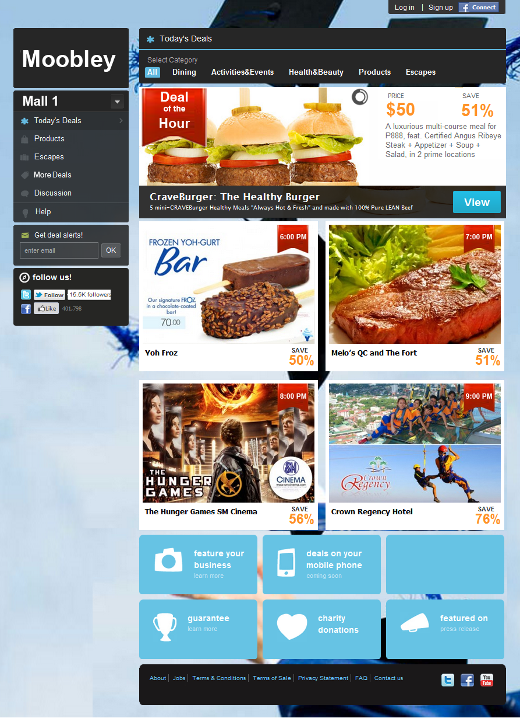

# Deal View - Highlights

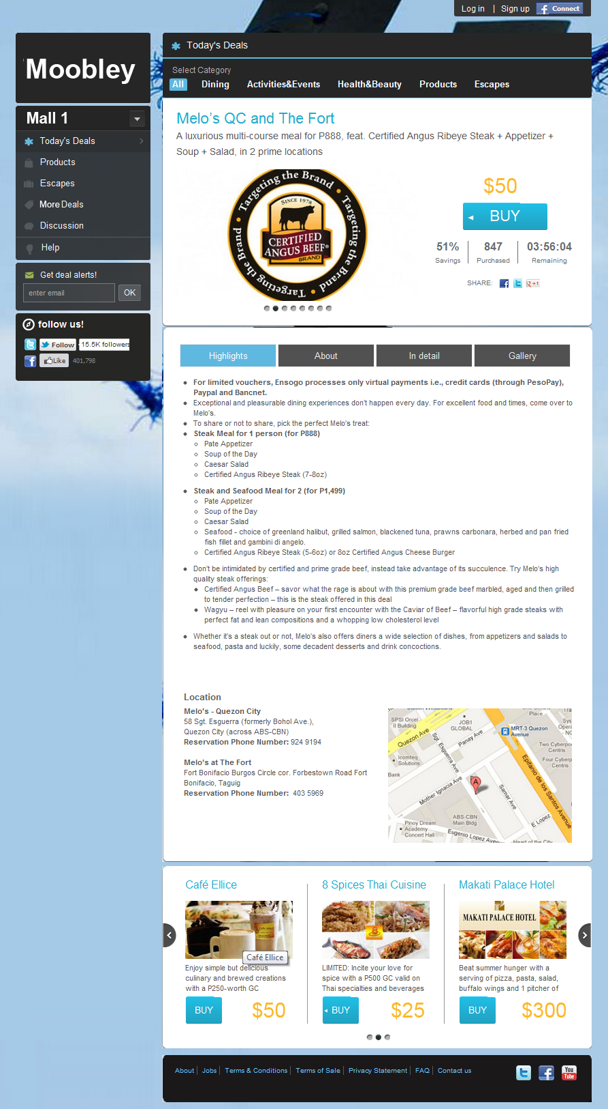

# Deal View – About

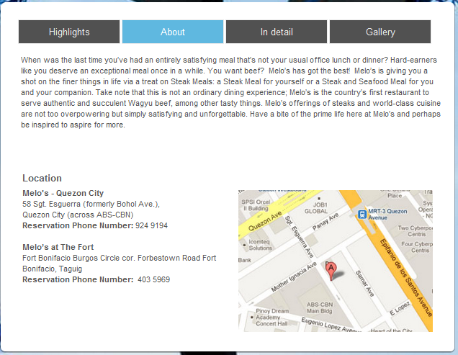

# Deal View – In Detail

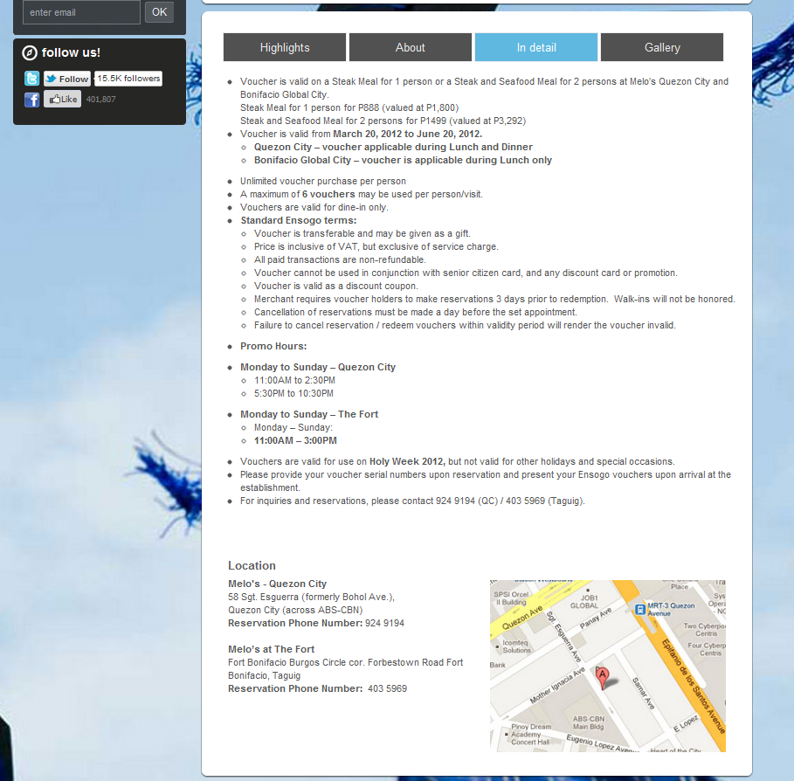

# Deal View – Gallery

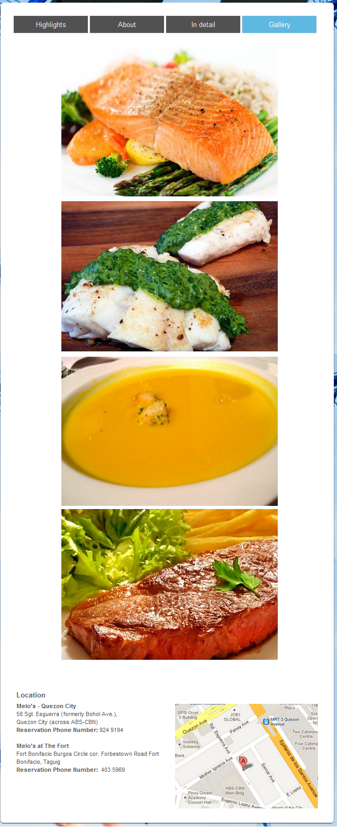

# More Deals

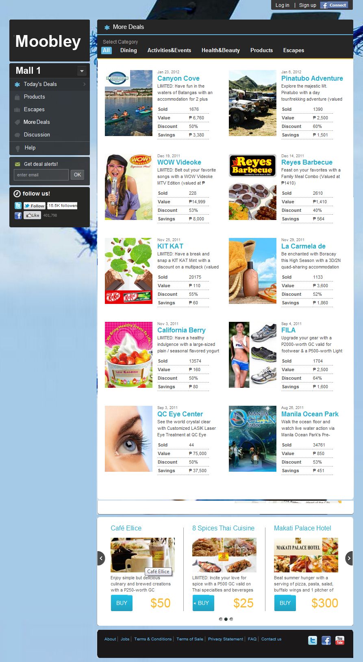

# More Deals

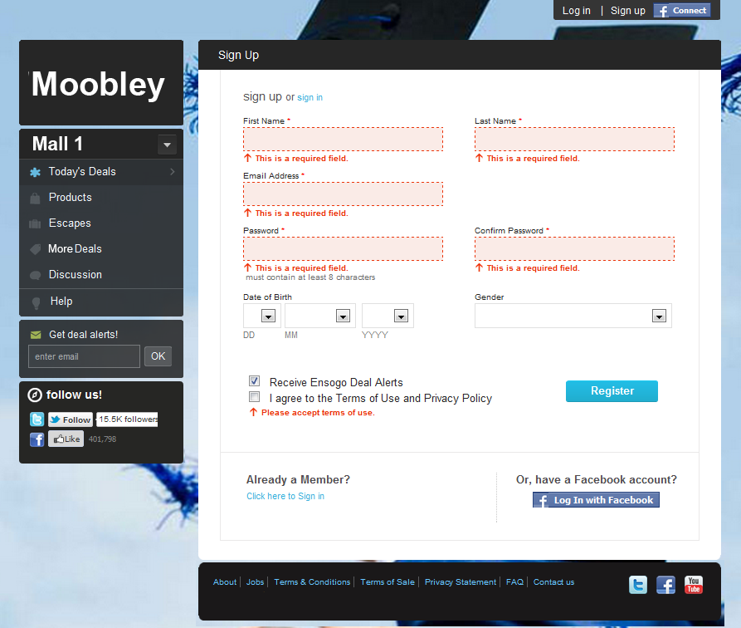

# Login

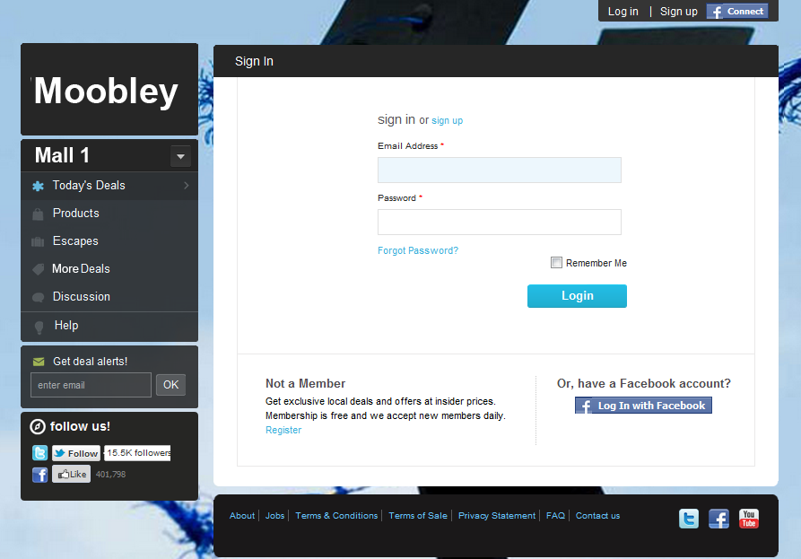

# Register



# My Account – Profile

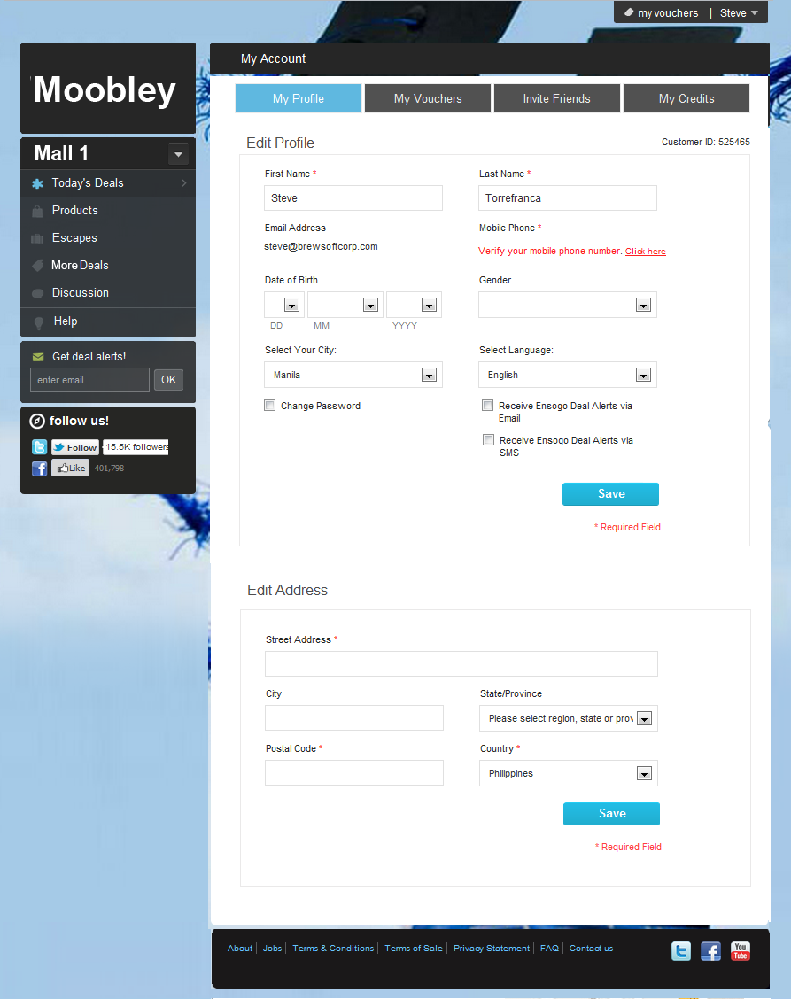

# My Account – Vouchers

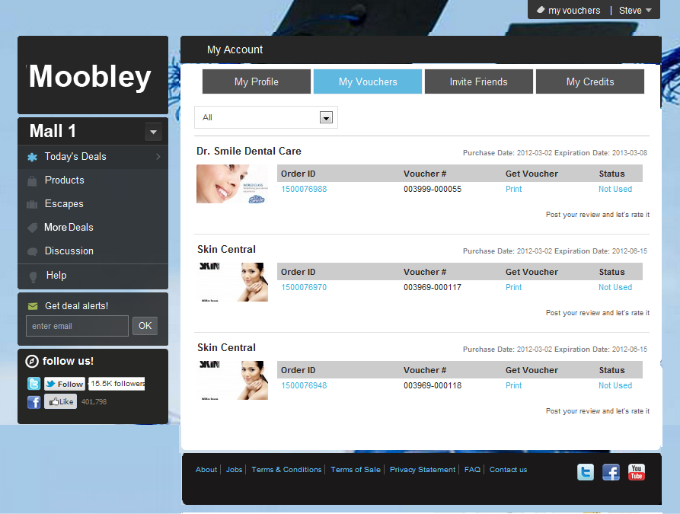

# My Account – Invite Friends

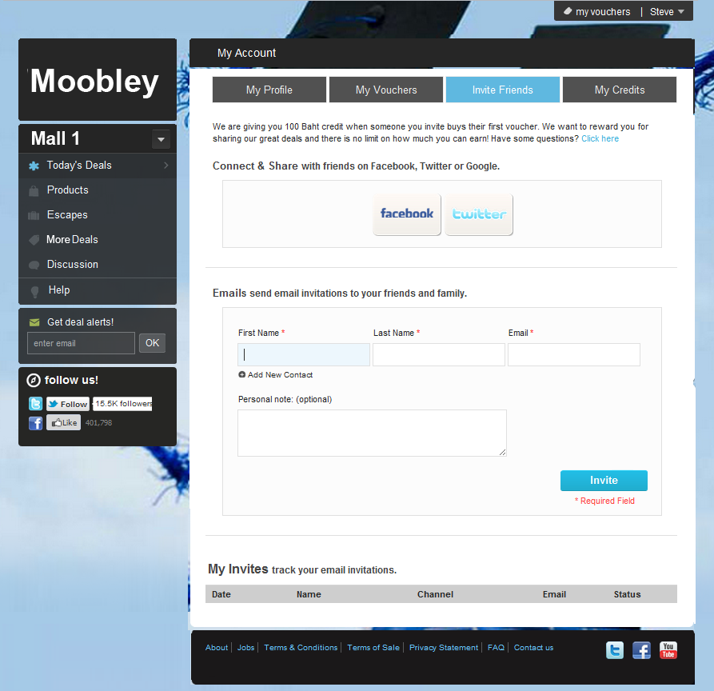

Merchant Screens:

Product Management – View/Search Products

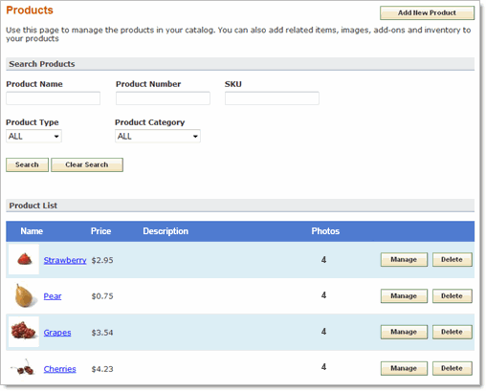

Product Management – Add/Edit Product

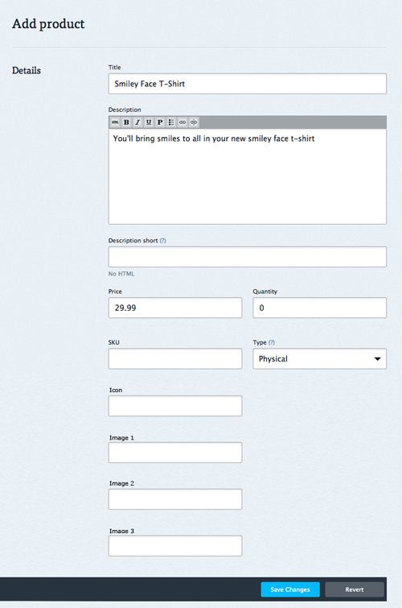

Coupon Management – Search Coupon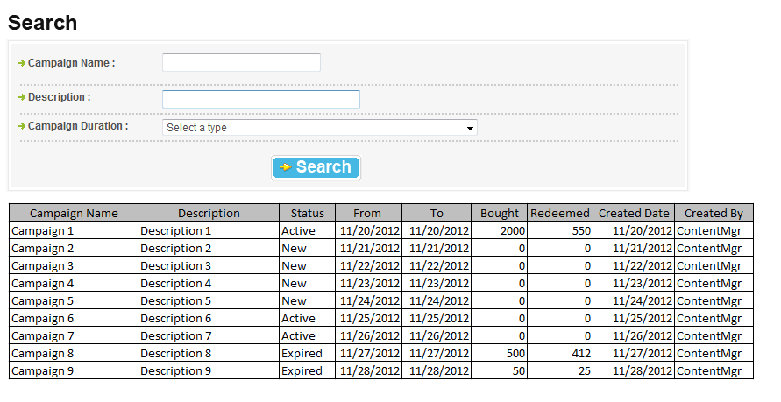

# Coupon Management – Unlimited Time Coupon

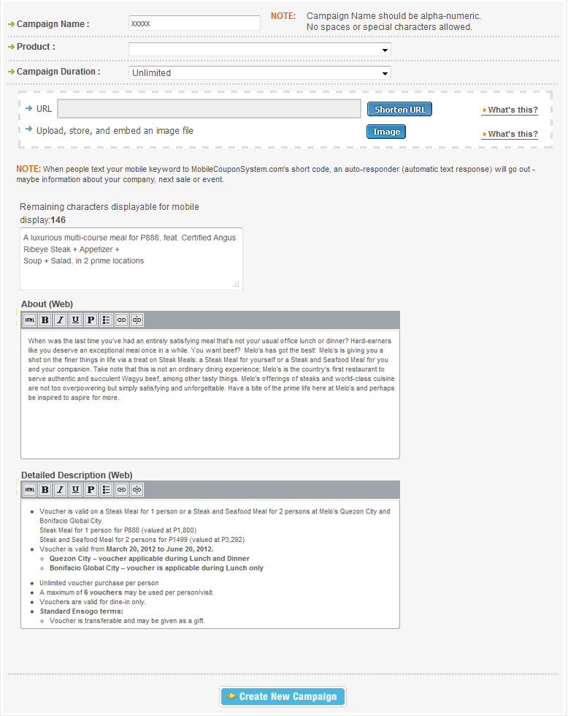

# Coupon Management –Fixed Time CouponC:\Users\Steve Torrefranca\Desktop\moby\c-1.pngC:\Users\Steve Torrefranca\Desktop\moby\c-2.png

Mobile Interface:

# Welcome Page

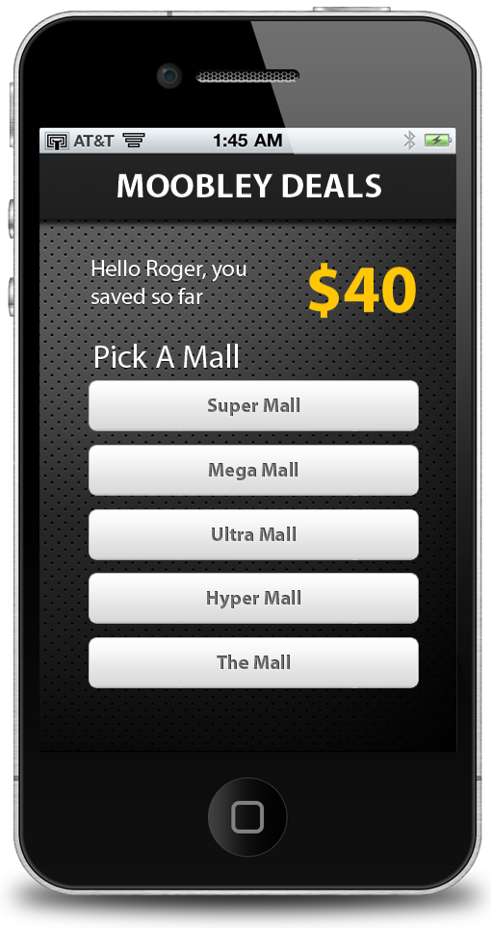

# Home Page – Deal of the Hour

# 

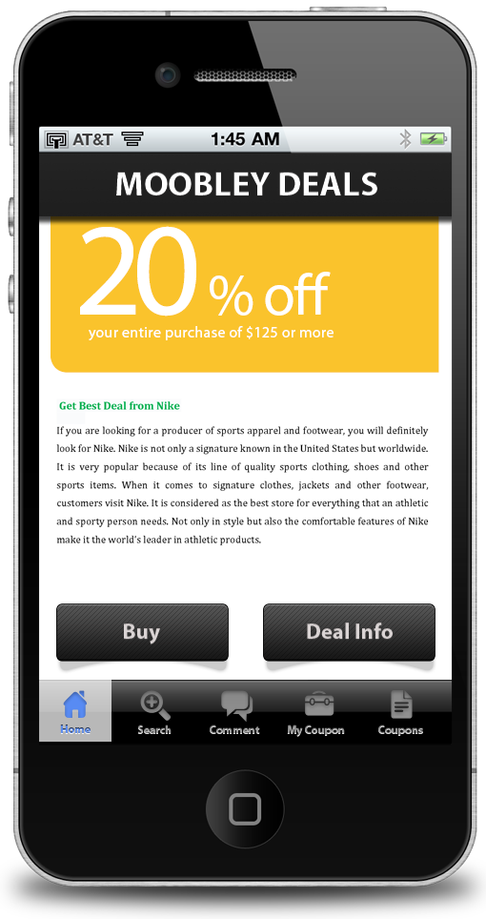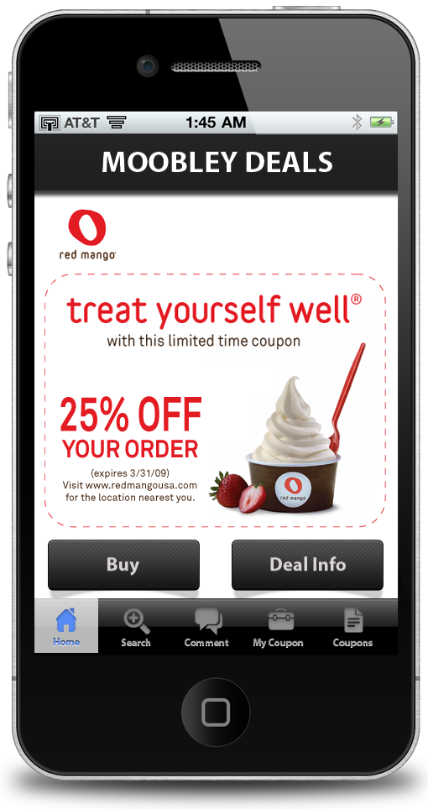

# More Coupons

